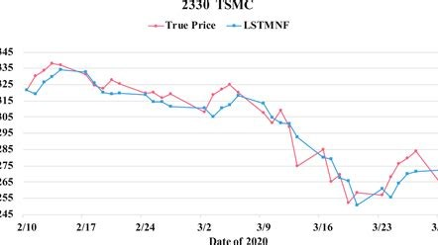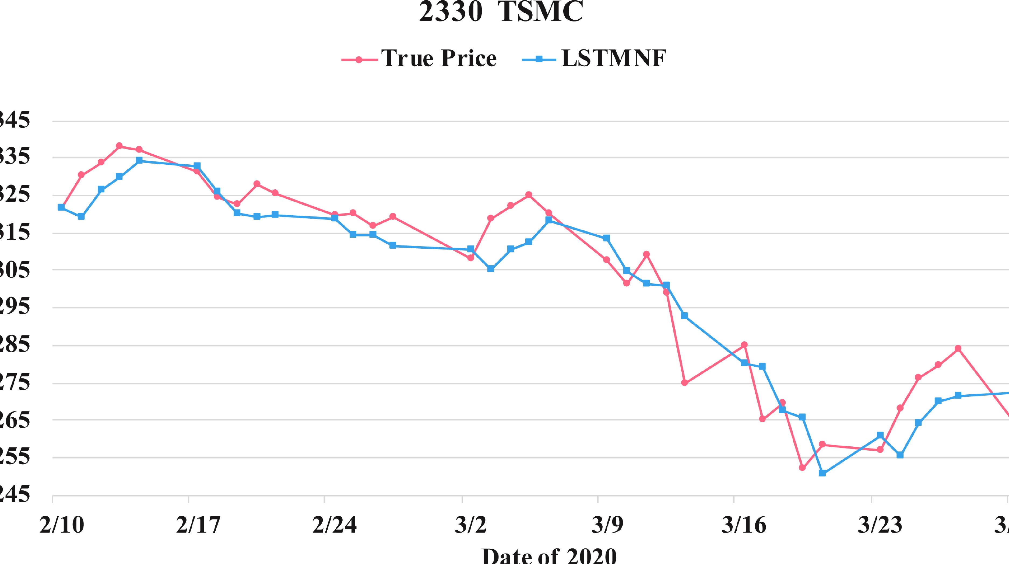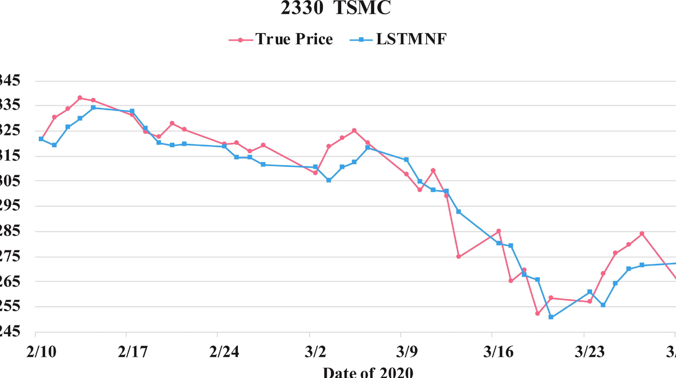

Predictive Modeling for Stock Price

Movement

The objective of this project is to develop a predictive model that leverages historical financial data,

technical indicators, and sentiment analysis to forecast stock price movements. The model will be an

invaluable tool for data scientists, machine learning engineers, and stakeholders in the finance industry.

**by manoj kumar**



Data Collection

Gathering data is a critical first step in the predictive modeling process. It involves sourcing historical

stock price data, financial statements, and economic indicators. Additionally, utilizing APIs for real-time

market data and collecting news articles and social media data for sentiment analysis are essential tasks.

The collected information forms the foundation for subsequent analysis and model development.

1

Historical Data

Gather historical stock price data, financial statements, and economic indicators.

2

Real-Time Data

Utilize APIs to fetch real-time market data and collect news articles and social media data

for sentiment analysis.

Data Cleaning and Preprocessing

Once the data is collected, the next crucial step is to clean and preprocess it. This involves addressing

missing values, outliers, and inconsistencies within the dataset, as well as normalizing and scaling

numerical features. Text data for sentiment analysis also needs to be tokenized and preprocessed to

ensure optimal results.

Handling Data Anomalies

Address missing values, outliers, and

inconsistencies in the data.

Numerical Feature Processing

Normalize and scale numerical features for

consistency and accuracy.

Feature Engineering

Feature engineering is a critical aspect of predictive modeling, involving the creation of relevant financial

indicators and the extraction of sentiment scores from news articles and social media data. Additionally,

features must be engineered to capture market trends and economic conditions, which are crucial for

accurate predictions.



Market Trends

Engineer features to capture market trends and

economic conditions.



Financial Indicators

Create relevant financial indicators for accurate

predictions.

Model Selection and Training

Exploring various machine learning algorithms suitable for time-series prediction is a critical task in this

stage. Algorithms such as LSTM, Random Forest, and Gradient Boosting will be considered. Additionally,

the data will be split into training and testing sets, and the models will be fine-tuned and optimized for

accuracy and robustness.

Exploration of Algorithms

Explore various machine learning algorithms

suitable for time-series prediction.

Model Optimization

Fine-tune models and optimize for accuracy and

robustness.

Evaluation Metrics

Utilizing appropriate metrics such as Mean Squared Error (MSE), Root Mean Squared Error (RMSE), and

accuracy is essential to measure the model's performance. Cross-validation will also be performed to

ensure the generalization and reliability of the developed predictive model.

Mean Squared Error (MSE)

Measure error through squared differences

between predicted and actual values.

Root Mean Squared Error (RMSE)

Provide a measure of the differences between

predicted and actual values, adjusted for

sample size.

Accuracy

Evaluate the overall accuracy of the predictive

model.



Visualization

Interactive visualizations representing stock price predictions against actual prices will be

crucial in conveying the model's results. Furthermore, the development of user-friendly

dashboards will provide stakeholders with an intuitive interface for accessing and interpreting

the forecasts.

1

Interactive Visualizations

Create interactive visualizations representing stock price predictions against

actual prices.

2

User-Friendly Dashboards

Develop dashboards to provide a user-friendly interface for stakeholders.

Explanatory Analysis

Conducting a comprehensive feature importance analysis will interpret the influence of various factors on

stock price movements. This analysis will provide valuable insights into the model's predictions and

limitations, facilitating a deeper understanding of its functionality and practical implications.

1

Feature Importance Analysis

Interpret the impact of various factors on stock price movements.

Deployment and Documentation

Deploying the model in a production environment using relevant tools and frameworks will be pivotal for

its practical utilization. Additionally, preparing comprehensive documentation detailing the project, data

sources, methodologies, and results, along with a user guide for stakeholders, will ensure transparency

and effective utilization.

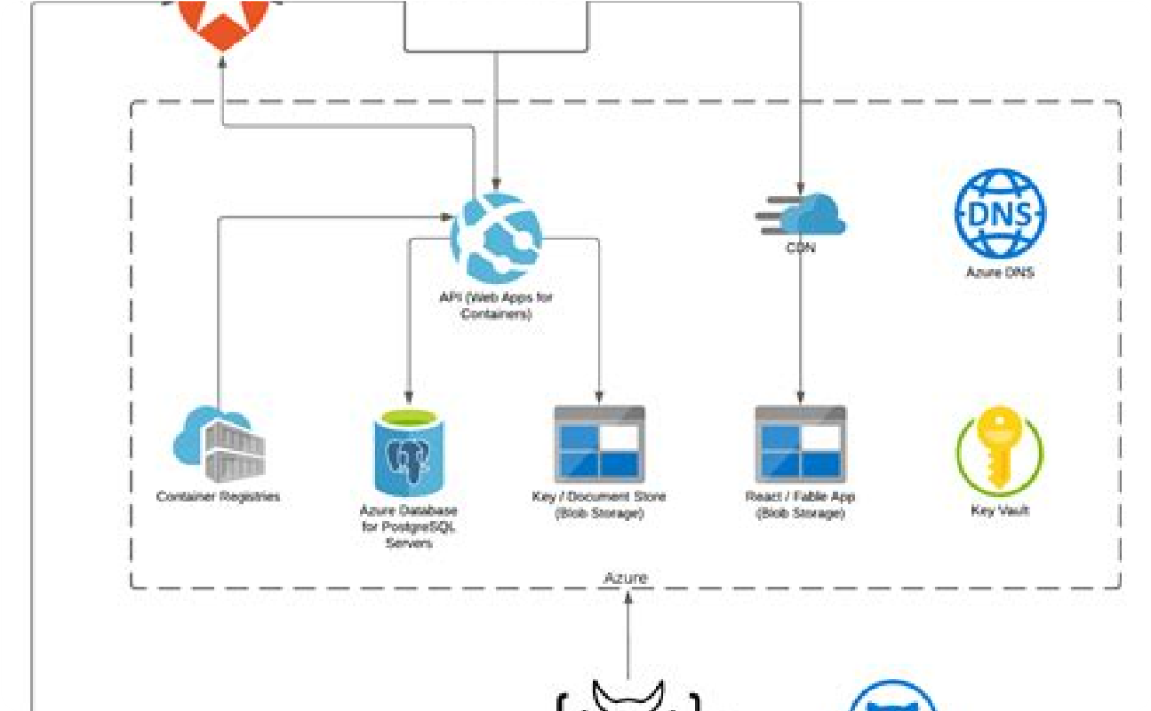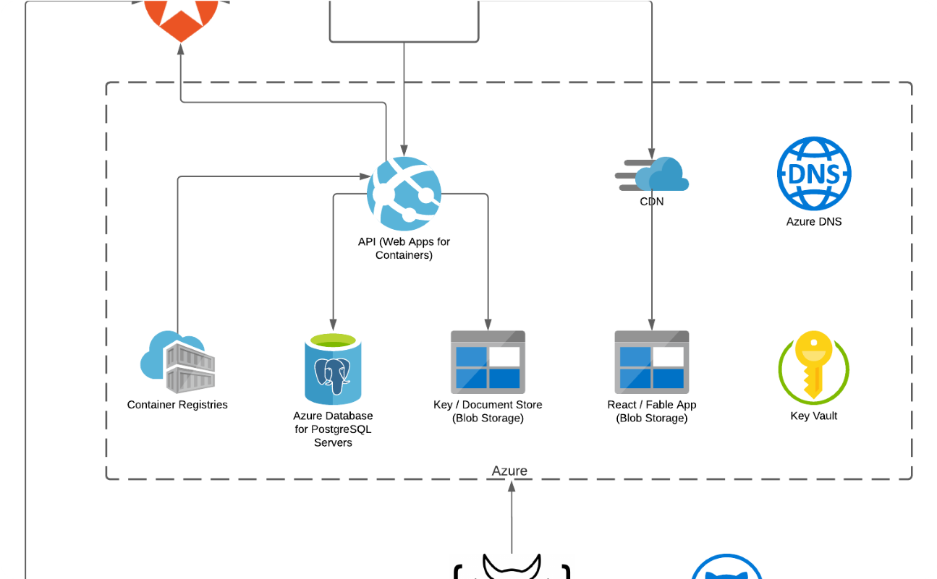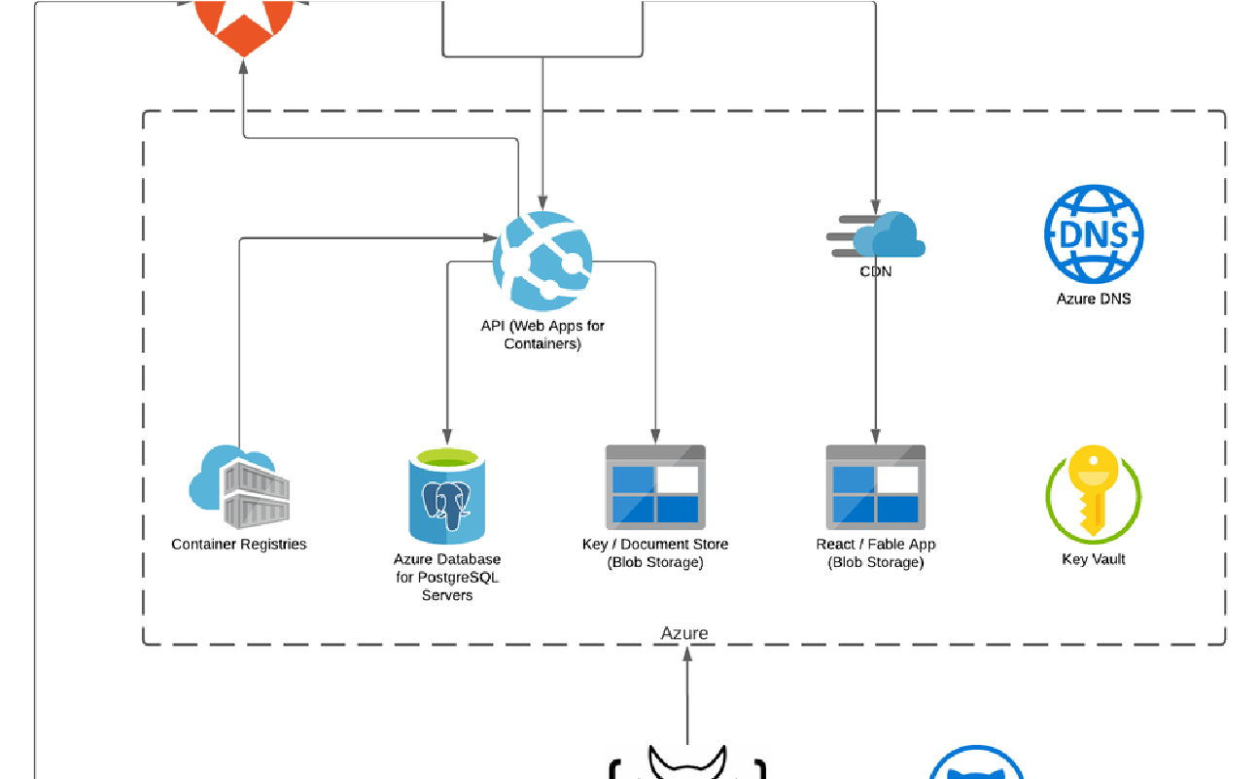

Model Deployment

Deploy the model in a production environment

using relevant tools and frameworks.



Comprehensive Documentation

Prepare detailed documentation detailing the

project, data sources, methodologies, and results.